

**Faculty of engineering - Shoubra**

**Benha University**

**Research Article / Research Project / Literature Review**

in fulfillment of the requirements of

|  |  |
| --- | --- |
| **Department** | Engineering mathematics and physics |
| **Division** | -------------- |
| **Academic Year** | 2019-2020 preparatory |
| **Course name** | Computer |
| **Course code** | ECE001 |

**Title: -**

Programming languages

By:

|  |  |  |  |
| --- | --- | --- | --- |
|  | Name | Edu mail | B.N |
| 1 | مصطفى محمد عبد المنعم رمضان | Mustafa196034@feng.bu.edu.eg | 928 |

**Approved by:**

|  |  |
| --- | --- |
| Examiners committee | Signature |
| Dr. Ahmed Bayoumi |  |
| Dr. shady Elmashad |  |
| Dr. Abdelhamid Attaby |  |
|  |  |
|  |  |

**Name :** Mustafa Mohammed abdul-munim Ramadan

**B.N:** 928

**Date :** 2/6/2020

**Topic:** programming languages

**Github link :**

**Github page :**

**Application brief**

Our future will be shaped by many emerging technologies and these new technologies all run on various programming languages. Learn the right programming language today and it will open up doors of opportunity, putting you right in the middle of exciting fields such as Mobile Development, Blockchain and Artificial Intelligence.

Here are 7 programming languages, some rather new and some quite old, that promise to have leading roles in key technologies of the future which are swift, kotlin, Dart, C++, solidity, python and GO .and I will take about four of them below .

1. **Swift language :** is a relatively young programming language. It first appeared in 2014, after being developed by Apple as a replacement for Objective-C. It quickly gained in popularity, particularly with iOS developers, as it made their code much more concise, quicker to write, and less prone to common errors than Objective-C .
2. **C++ language :** has been around since the mid-1980s, but it’s just as important today due to the role it plays in many emerging technologies. Foremost among these is block chain. The Bitcoin core code is written in C++ and so are other major blockchains such as Ripple, Litecoin, Monero, EOS and Stellar.
3. **Python language :** python language has been around for awhile and is often the first language taught in Computer Science courses because it’s so easy to learn. Python can be used to write functional, object orientated or procedural styles of programming. It has a large number of existing libraries and a very readable syntax that makes it quick to develop and ideal for working in larger developer teams .
4. **Solidity language :** is another programming language to consider learning if you would like to break into blockchain development. The main use cases for Solidity are decentralized applications and smart contracts running on the Ethereum platform.

**Screenshots**

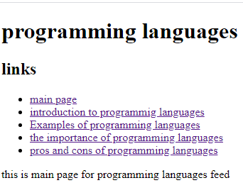

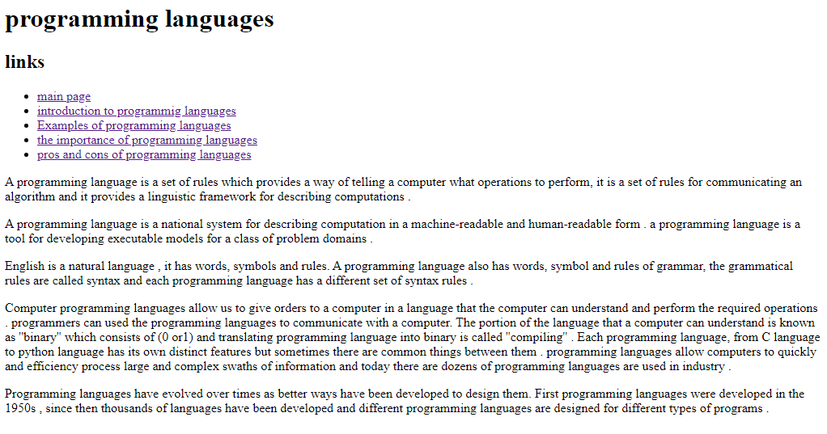

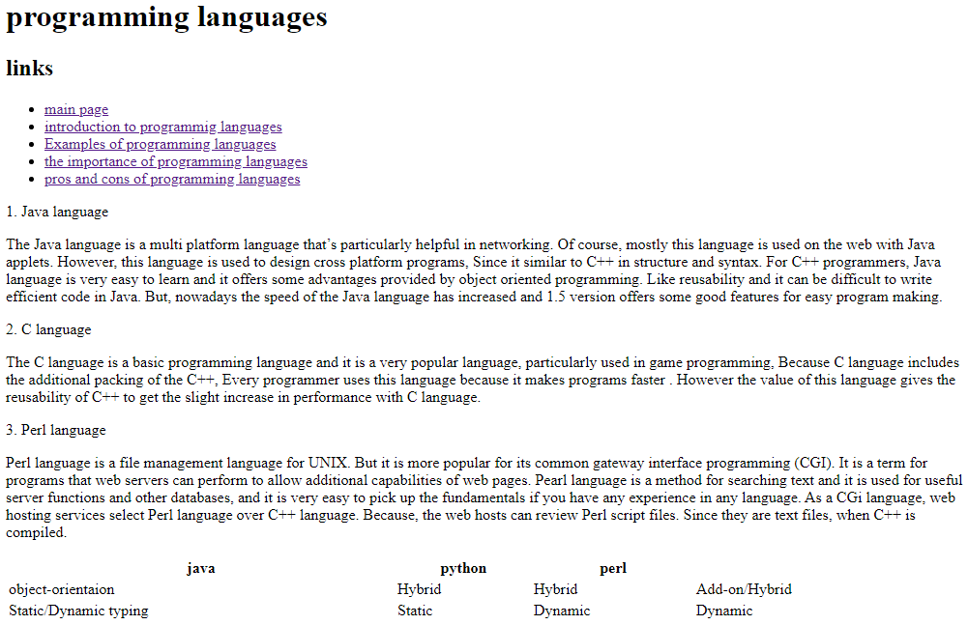

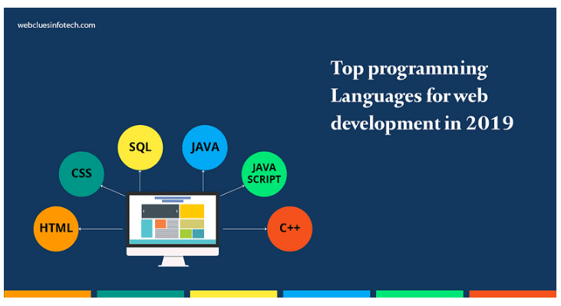

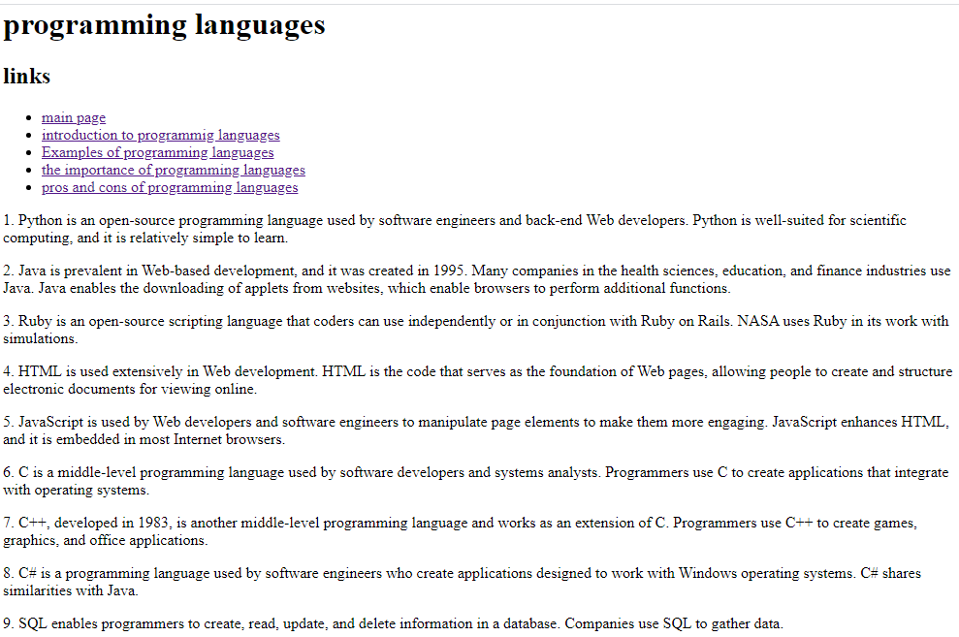

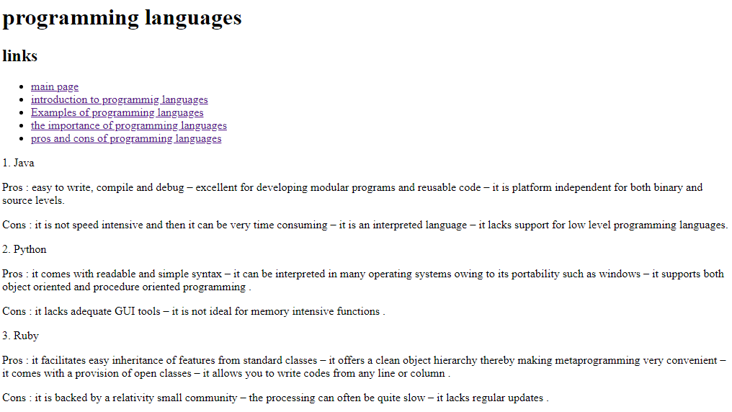

**Source code**

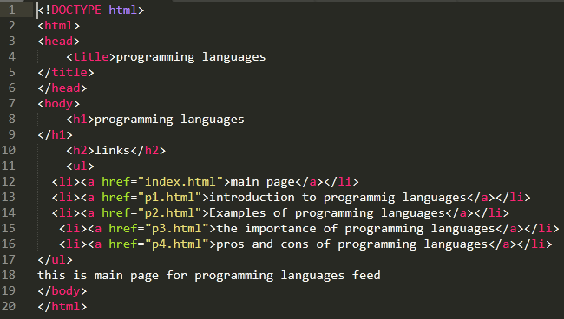

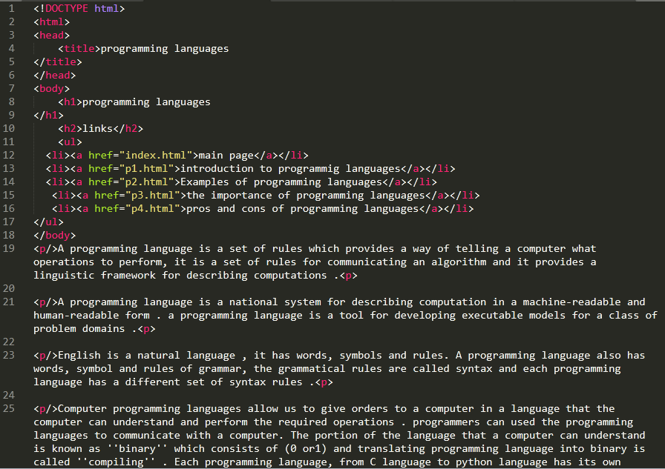

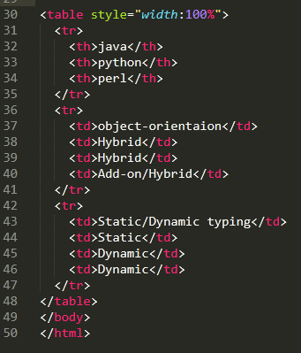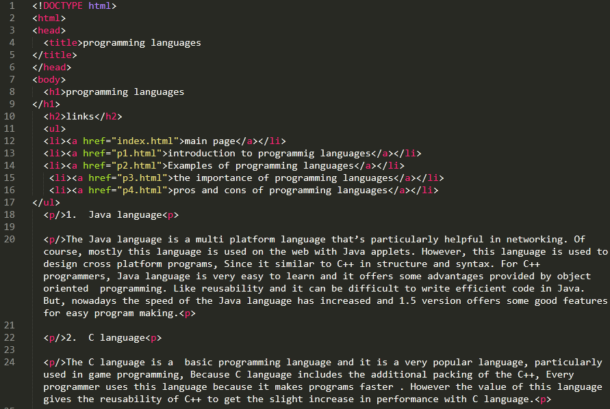

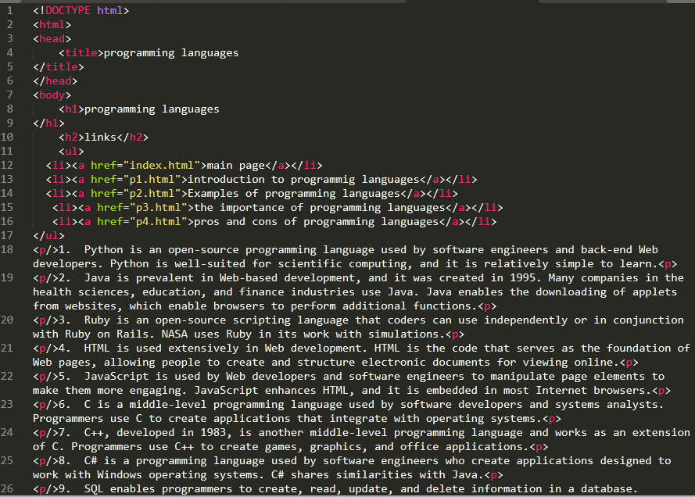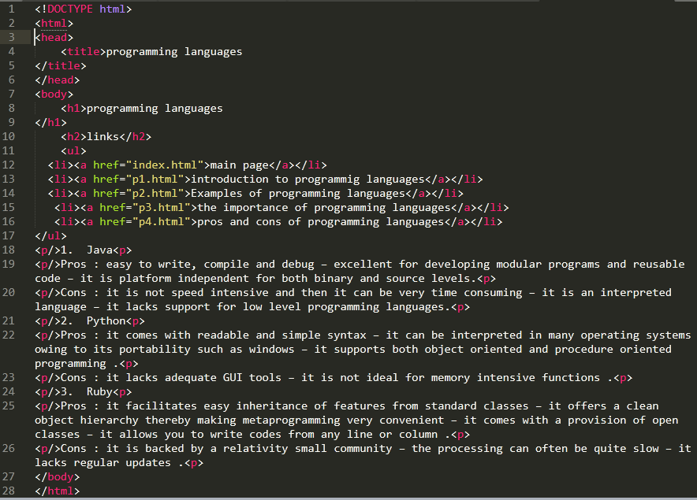

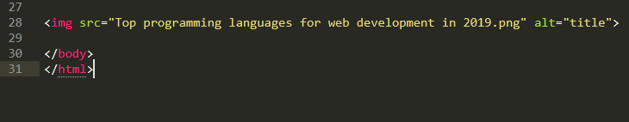

**References**

1. <https://www.slideshare.net/VarunGarg7/lect-1-introduction-to-programming-languages>
2. <https://wowjava.files.wordpress.com/2009/01/comarison.jpg>
3. <https://www.typesnuses.com/types-of-programming-languages-with-differences/>
4. <https://www.computerscience.org/resources/computer-programming-languages/>
5. <https://yourstory.com/mystory/top-programming-languages-for-web-development-in-2-fye36jfeuj>
6. <https://www.codingninjas.com/blog/2018/08/20/pros-and-cons-of-open-source-programming-languages/>
7. <https://iglu.net/programming-languages-future/>